Villa Theresa

Activities are Subject to Change
Sunday | Monday | Tuesday | Wednesday | Thursday | Friday | Saturday
 |  |  | 1  9:15 Aquatic Exercise  11:00 Mass PB  3:00 Bingo w/ Sharon AH  Game Center | 2  8:45 Exercise Class AH  11:00 Communion Service PB  1:00 Chapel with Chris Brown PB  Game Center | 3  9:15 Aquatic Exercise  10:00 Balance Class AH  11:00 Mass PB  2:00 Happy Hour w/ Sterling MDR | 4  2:00  For Fun  AH  *6:00 Cards AH  Game Center
5  11:00 Mass  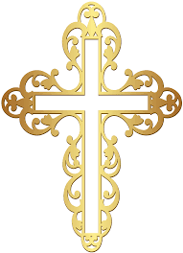  *Word wall pages AH  Game Center | 6  9:15 Aquatic Exercise  10:00 Balance Class AH  11:00 Mass PB  Game Center | 7  8:45 Exercise Class AH  11:00 Communion Service PB  3:00 Independent Dominos AH | 8  9:15 Aquatic Exercise  11:00 Mass PB  3:00 Bingo w/ Sharon AH  Game Center | 9  8:45 Exercise Class AH  11:00 Communion Service PB  3:00 Independent Cards AH  Game Center | 10  9:15 Aquatic Exercise  10:00 Balance Class AH  11:00 Mass PB  2:00 Cinco De Mayo Party MDR | 11  2:00  For Fun  AH  *6:00 Cards AH  Game Center
12  11:00 Mass  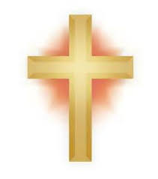  *Word wall pages AH  Game Center | 13  9:15 Aquatic Exercise  10:00 Balance Class AH  11:00 Mass PB  2:00 May Crowning PB  Mother’s Day Gathering after Mass MDR | 14  8:45 Exercise Class AH  11:00 Communion Service PB  3:00 Barbara Payne Presents Our Builings History. AH | 15  9:15 Aquatic Exercise  11:00 Mass PB  3:00 Bingo w/ Sharon AH  Game Center | 16  8:45 Exercise Class AH  11:00 Communion Service PB  3:00 Independent Wii Tennis AH  Game Center | 17  9:15 Aquatic Exercise  10:00 Balance Class AH  11:00 Mass PB  2:00 Happy Hour w/ Marty MDR | 18  2:00  For Fun  AH  *6:00 Cards AH  Game Center
19  11:00 Mass  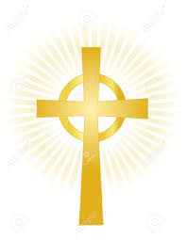  *Word wall pages AH  Game Center | 20  9:15 Aquatic Exercise  10:00 Balance Class AH  11:00 Mass PB  Game Center | 21  8:45 Exercise Class AH  11:00 Communion Service PB  12:30-2:00 Reconciliation PB  2:00 Sipping Club w/ Chris Brown MDR | 22  9:15 Aquatic Exercise  9:45-10:45 Library AH  11:00 Mass PB  3:00 Bingo w/ Sharon AH  Game Center | 23  8:45 Exercise Class AH  11:00 Communion Service PB  3:00 Independent Bunko  AH  Game Center | 24  9:15 Aquatic Exercise  10:00 Balance Class AH  11:00 Mass PB  2:00 Happy Hour w/ Matt Davis MDR | 25  2:00  For Fun  AH  *6:00 Cards AH  Game Center
26  11:00 Mass  *Word wall pages AH  Game Center | 27  9:15 Aquatic Exercise  11:00 Mass PB  Game Center | 28  8:45 Exercise Class AH  11:00 Communion Service PB  3:00 Bingo w/ Sharon AH  Game Center | 29  9:15 Aquatic Exercise  11:00 Mass PB  2:00 Birthday Party MDR  Game Center | 30  8:45 Exercise Class AH  11:00 Communion Service PB  1:00 Chapel with Chris Brown PB  3:00 Independent Cards AH  Game Center | 31  9:15 Aquatic Exercise  10:00 Balance Class AH  11:00 Mass PB  2:00 Happy Hour w/ Ray Volmer MDR | Drink of the Month...  May Day Mimosa

